Axiom Requisition Copy Service
447 North Canal Road, Lansing, Michigan 48917
517.886.5099 – 877.886.5090 toll free – 517.886.4116 facsimile

Gregory T. Smith, Esquire
Rosencranz & Associates
One Center Plaza, Suite 220
Boston, MA 02108

RE: Labor vs. Castellano
Suffolk County Boston Municipal Court Division Civil Action No.: 0801CV3182

Dear Attorney Smith:

Attached pursuant to Rule 30 and Rule 45 of the Massachusetts Rules of Civil Procedure, is a copy of the Keeper of Records Notice of Taking Deposition and Subpoena for the following locations and relating to the above-captioned matter:

National Grange Mutual Insurance Company (Insurance Records)

Thank you for your attention to this matter.

Very truly yours,
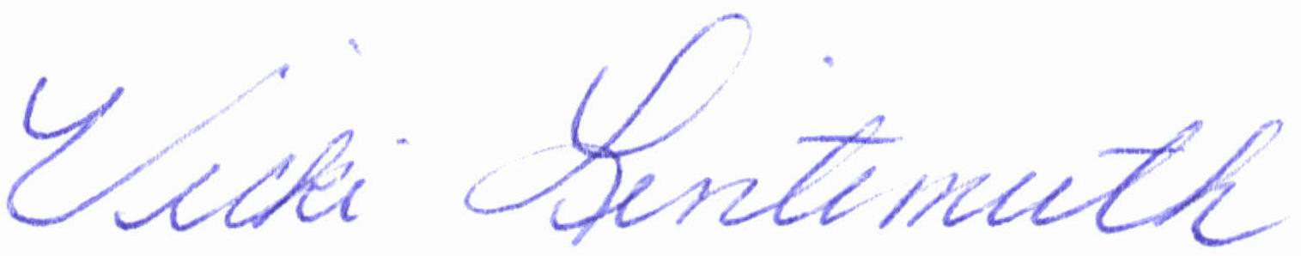

Vicki Lintemuth

Enclosure
Order No. 01-17912-003

